CSAY OBSTACLE HEIGHT CALCULATION

User Manual

of

(Version 2023.1)

(A free and open-source software)

Er. AJAY YADAV

2023

Based

on

ICAO ANNEX-14, VOL-I, OLS

Table of Content

LIST OF FIGURES i

CHAPTER 1 DEFINITION 1

1.1 Definitions as per ICAO Annex 14 1

1.1.1 Aerodrome 1

1.1.2 Balked Landing 1

1.1.3 Aerodrome Reference point 1

1.1.4 Clearway 1

1.1.5 Displaced Threshold 1

1.1.6 Obstacle 1

1.1.7 Obstacle Free Zone (OFZ) 2

1.1.8 Obstacle Limitation Surface (OLS) 2

1.1.9 Runway 2

1.1.10 Runway strips 2

1.1.11 Threshold 2

CHAPTER 2 OBSTACLE LIMITATION SURFACE 3

2.1 Types of Obstacle Limitation Surfaces 3

2.2 OLS requirement 3

2.3 Details of each OLS 4

2.3.1 Conical Surface 4

2.3.2 Inner Horizontal Surface 5

2.3.3 Inner Approach Surface 6

2.3.4 Approach Surface 7

2.3.5 Transitional Surface 8

2.3.6 Inner Transitional Surface 8

2.3.7 Balked Landing Surface 10

2.3.8 Take Off Climb Surface 11

2.3.9 Outer Horizontal Surface 12

CHAPTER 3 INTRODUCTION TO SOFTWARE 13

3.1 Overview of Software 13

3.2 Functions of Software 13

3.3 Limitation of Software 13

3.4 Layout of Software 13

3.5 Input Text files (“*.txt”) and folder 14

3.5.1 Content of TextBox Folder 15

3.5.2 Airport code folder content 16

3.5.3 MultiObstacle input format 18

3.5.4 Others Texfile input format 18

3.6 Content of Tab 19

3.6.1 Load All Record 19

3.6.2 RWY COORD and Eq 20

3.6.3 OLS Map 21

3.6.4 General 22

3.6.5 Letters and others 22

3.6.6 Calculation Detail 23

3.6.7 RWY Classification and other 24

3.6.8 RL of RWY CL 24

3.6.9 Coord Trans 25

3.6.10 Multi-Obstacle data Tab 25

3.6.11 Menu 26

3.6.12 Filter 28

3.7 Nomenclature of Runway corners 28

3.8 Plot case of Obstacle 29

3.9 Output 30

3.9.1 Report 30

3.9.2 Letter in Nepali 31

3.9.3 Tippani in Nepali 32

3.9.4 Letter in English 33

3.10 Steps to calculate Obstacle Height with Auot-Process 33

# LIST OF FIGURES

Figure 1. Rwy, Strip and other detail 2

Figure 2. Conical Surface 4

Figure 3. Inner Horizontal Surface 5

Figure 4. Inner Approach Surface 6

Figure 5. Approach Surface 7

Figure 6. Transitional Surface 8

Figure 7. Inner Transitional Surface (AB Side) 9

Figure 8. Inner Transitional Surface (CD Side) 9

Figure 9. Balked Landing Surface 10

Figure 10. Take off Climb Surface 11

Figure 11. Outer Horizontal Surface 12

Figure 12. Dos for preparing any input ".txt" files 14

Figure 13. Don'ts for preparing any ".txt" files 14

Figure 14. Input folder and its content 15

Figure 15. TextBox Folder Content 15

Figure 16. Airport Code (e.g., VNBW) Folder Content 16

Figure 17. MultiObstacle folder content 18

Figure 18. Other textfile content format 18

Figure 19. Load all Records Tab 19

Figure 20. RWY COORD and Eq Tab 20

Figure 21. OLS Map Tab 21

Figure 22. DMS to DD Converter 21

Figure 23. General Tab 22

Figure 24. Letters and Others Tab 23

Figure 25. Calculation Detail 23

Figure 26. RWY Classification and other Tab 24

Figure 27. RL of RWY CL tab 24

Figure 28. Coord Trans tab 25

Figure 29. Multi-Obstacle data tab 25

Figure 30. Menu 26

Figure 31. About 27

Figure 32. Message and recently saved location (Orange region) 27

Figure 33. Filter 28

Figure 34. Runway corner nomenclature 29

Figure 35. Plot case of obstacle 29

Figure 36. Software Executable file Location 34

# DEFINITION

## Definitions as per ICAO Annex 14

### Aerodrome

A defined area on land or water (including any buildings, installations and equipment) intended to be used either wholly or in part for the arrival, departure and surface movement of aircraft.

### Balked Landing

A landing manoeuvre that is unexpectedly discontinued at any point below the obstacle clearance altitude/height (OCA/H).

### Aerodrome Reference point

The designated geographical location of an aerodrome

### Clearway

A defined rectangular area on the ground or water under the control of the appropriate authority, selected or prepared as a suitable area over which an aeroplane may make a portion of its initial climb to a specified height.

### Displaced Threshold

A threshold not located at the extremity of a runway

### Obstacle

All fixed (whether temporary or permanent) and mobile objects, or parts thereof, that:

a) are located on an area intended for the surface movement of aircraft; or

b) extend above a defined surface intended to protect aircraft in flight; or

c) stand outside those defined surfaces and that have been assessed as being a hazard to air navigation.

### Obstacle Free Zone (OFZ)

The airspace above the inner approach surface, inner transitional surfaces, and balked landing surface and that portion of the strip bounded by these surfaces, which is not penetrated by any fixed obstacle other than a low-mass and frangibly mounted one required for air navigation purposes.

### Obstacle Limitation Surface (OLS)

It defines the limit to which objects may project into the airspace

### Runway

A defined rectangular area on a land aerodrome prepared for the landing and take-off of aircraft.

### Runway strips

A defined area including the runway and stopway, if provided, intended:

a) to reduce the risk of damage to aircraft running off a runway; and

b) to protect aircraft flying over it during take-off or landing operations.

### Threshold

The beginning of that portion of the runway usable for landing.

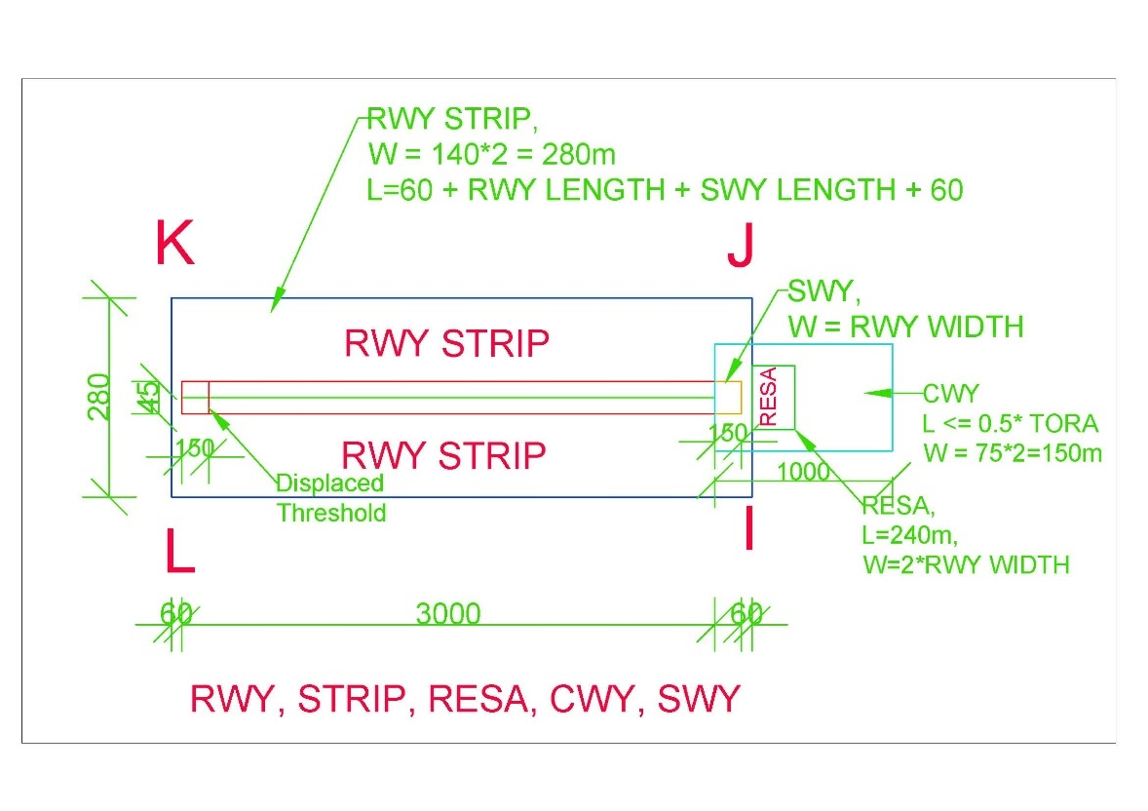

Figure 1. Rwy, Strip and other detail

# OBSTACLE LIMITATION SURFACE

## Types of Obstacle Limitation Surfaces

1. CONICAL SURFACE
2. INNER HORIZONTAL SURFACE
3. INNER APPROACH SURFACE
4. APPROACH SURFACE
5. TRANSITIONAL SURFACE
6. INNER TRANSITIONAL SURFACE
7. BALKED LANDING SURFACE
8. TAKEOFF CLIMB SURFACE
9. OUTER HORIZONTAL SURFACE

## OLS requirement

|  |  |  |
| --- | --- | --- |
| Runway Category | Runway Sub-Category | Obstacle Limitation surface |
| Non-Instrument Runway |  | 1. Conical surface 2. Inner Horizontal 3. Approach surface 4. Transitional surface |
| Instrument Runway | Non-Precision Approach Runway | 1. Conical surface 2. Inner Horizontal 3. Approach surface 4. Transitional surface |
| Precision Approach Runway Category I | Mandatory Surfaces (Shall be)   1. Conical surface 2. Inner Horizontal 3. Approach surface 4. Transitional surface   *Optional Surfaces (Should be)*   1. *Inner Approach surface* 2. *Inner Transitional surface* 3. *Balked landing surface* |
| Precision Approach Runway Category II or III | 1. Conical surface 2. Inner Horizontal 3. Approach surface 4. Transitional surface 5. Inner Approach surface 6. Inner Transitional surface 7. Balked landing surface |

* Note – 1: Take off climb surface shall be established for all runways meant of Take off climb.

## Details of each OLS

In this document, calculations and drawings shall be based on “**PRECISION APPROACH RUNWAY CAT II OR III**” based on Table 4-1 Dimensions and slopes of obstacle limitation surfaces — Approach runways of ICAO ANNEX – 14, Vol – I, 9th Edition.

### Conical Surface

|  |  |
| --- | --- |
| Surfaces | Dimension |
| CONICAL |  |
| Slope_% | 5 |
| Height_m | 100 |

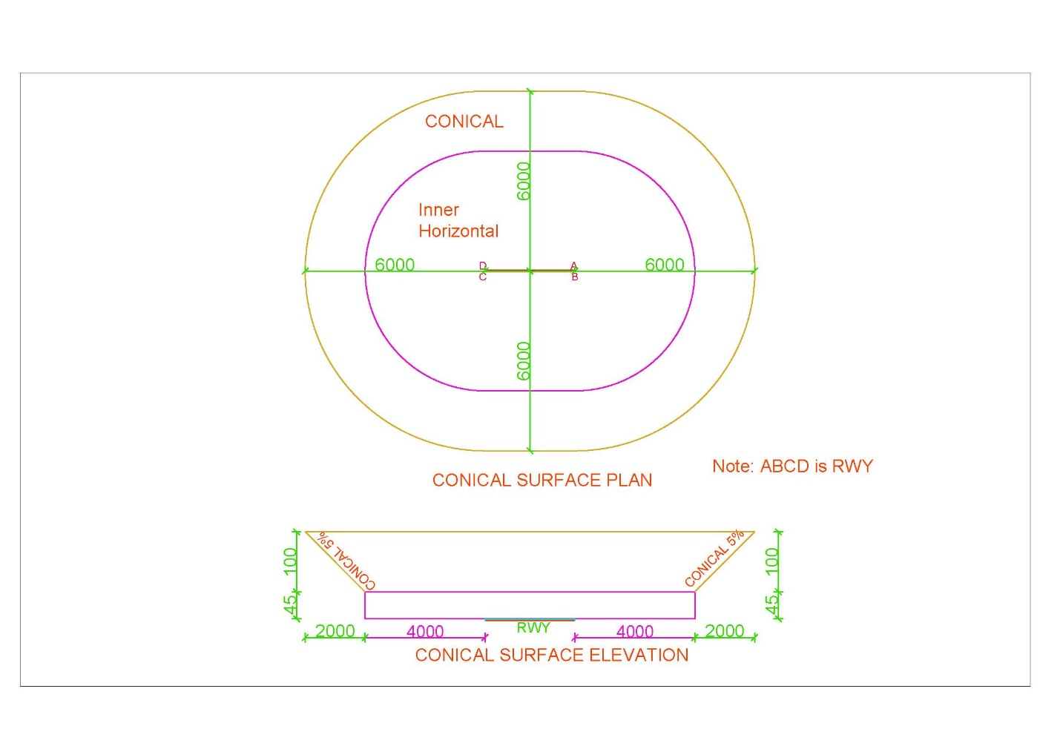

Figure 2. Conical Surface

### Inner Horizontal Surface

|  |  |
| --- | --- |
| Surfaces | Dimension |
| INNER_HORIZONTAL |  |
| Height_m | 45 |
| Radius_m | 4000 |

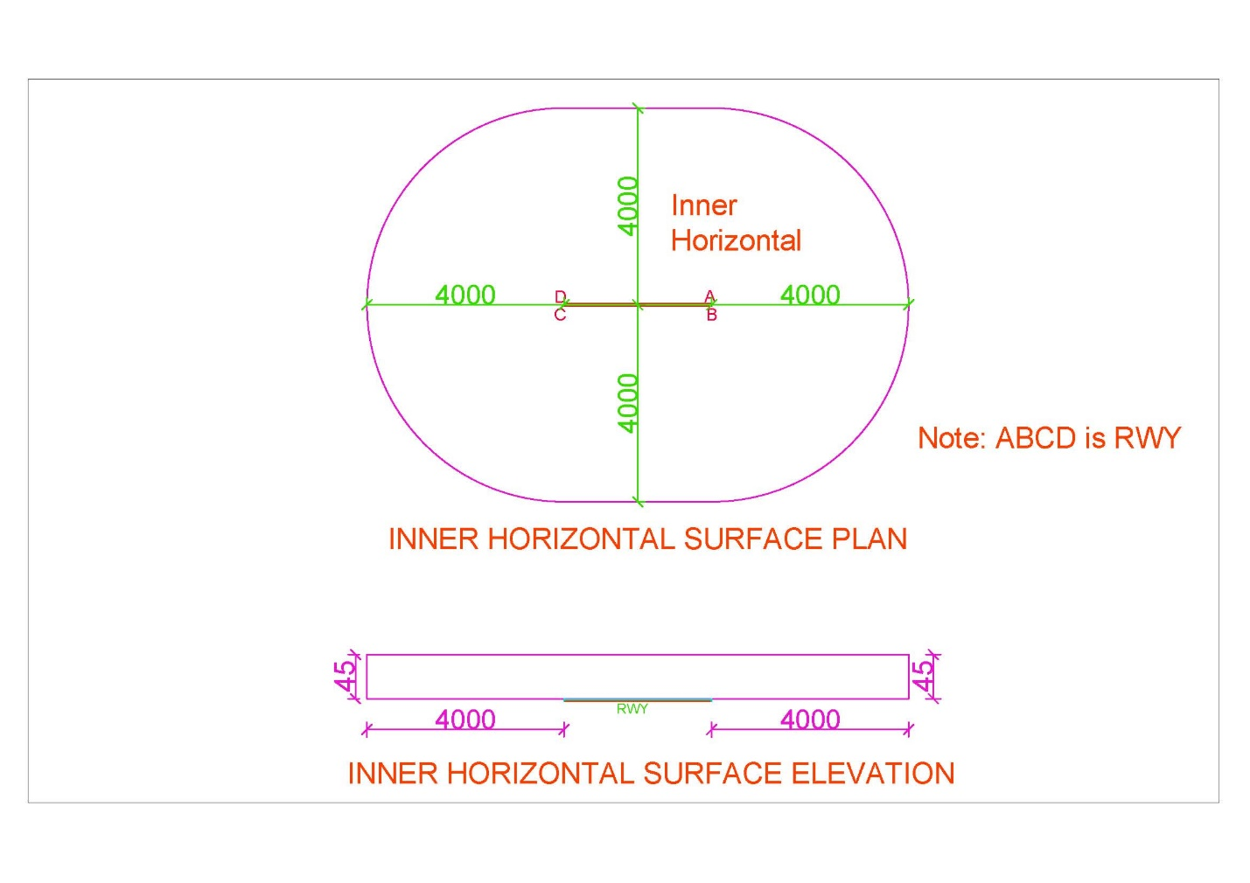

Figure 3. Inner Horizontal Surface

### Inner Approach Surface

|  |  |
| --- | --- |
| Surfaces | Dimension |
| INNER_APPROACH |  |
| Width_m | 120 |
| Distance_from_threshold_m | 60 |
| Length_m | 900 |
| Slope_% | 2 |

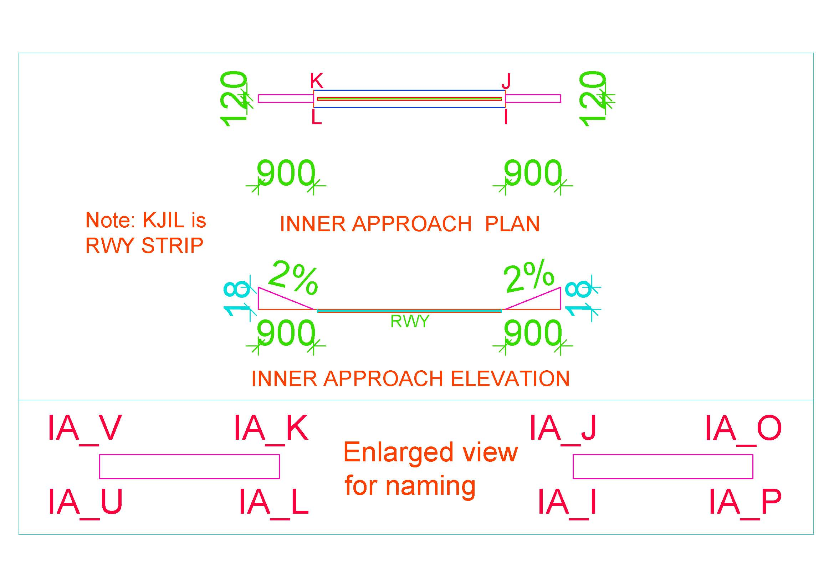

Figure 4. Inner Approach Surface

### Approach Surface

|  |  |  |  |
| --- | --- | --- | --- |
| Surfaces | Dimension | Surfaces | Dimension |
| Length_of_inner_edge_m | 280 | Second_Section |  |
| Distance_from_threshold_m | 60 | Length_m | 3600 |
| Divergence_% | 15 | Slope_% | 2.5 |
| First_Section |  | Horizontal_Section |  |
| Length_m | 3000 | Length_m | 8400 |
| Slope_% | 2 |  |  |

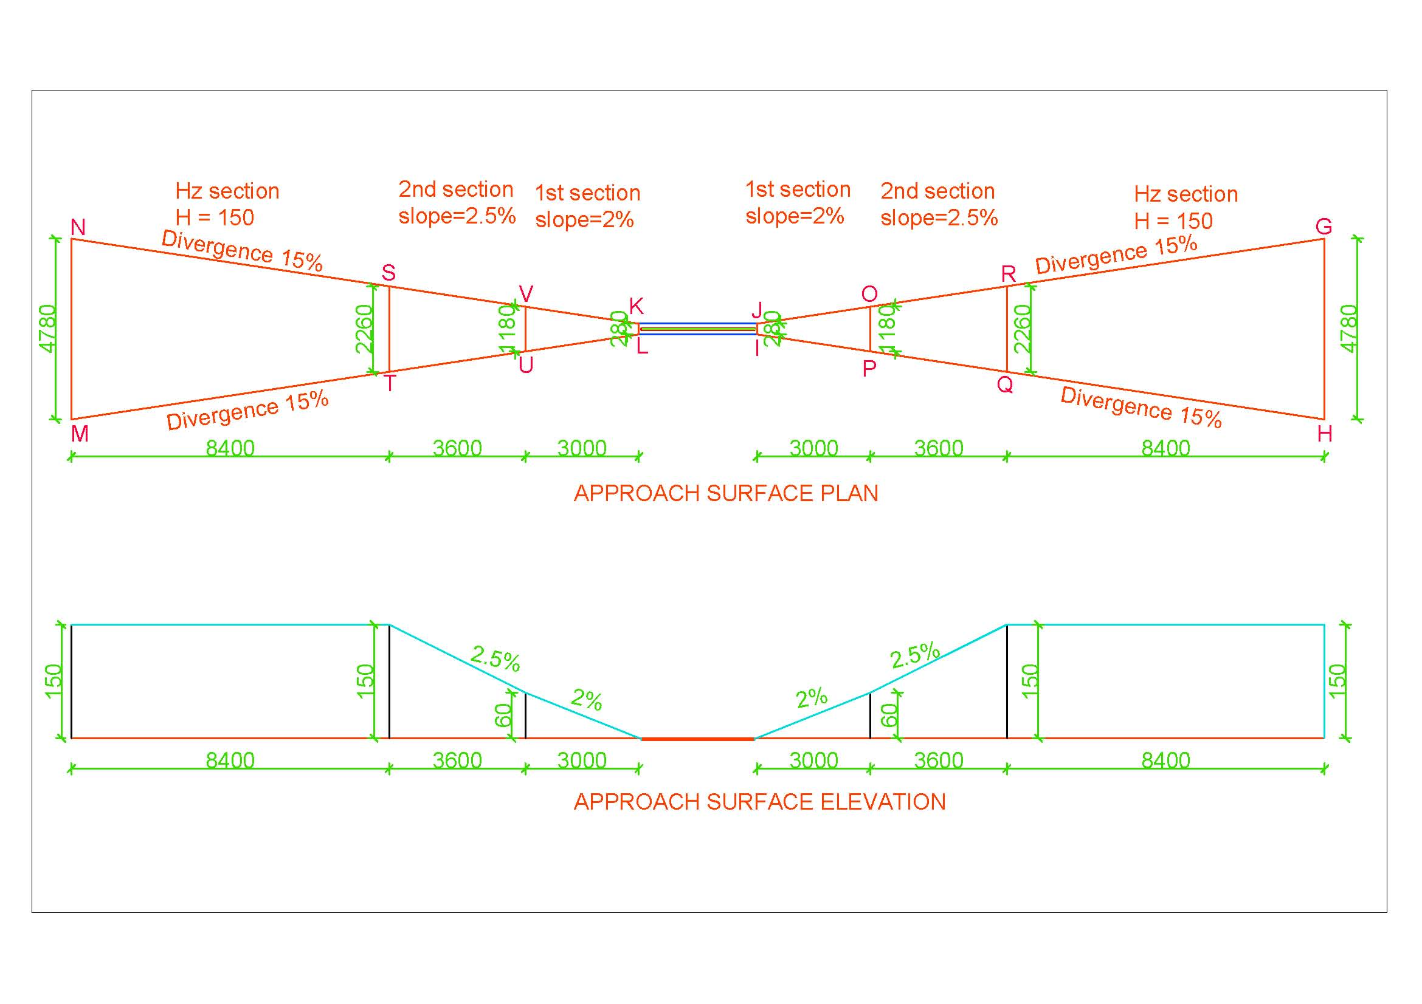

Figure 5. Approach Surface

### Transitional Surface

|  |  |
| --- | --- |
| Surfaces | Dimension |
| INNER_TRANSITIONAL |  |
| Slope_% | 14.3 |

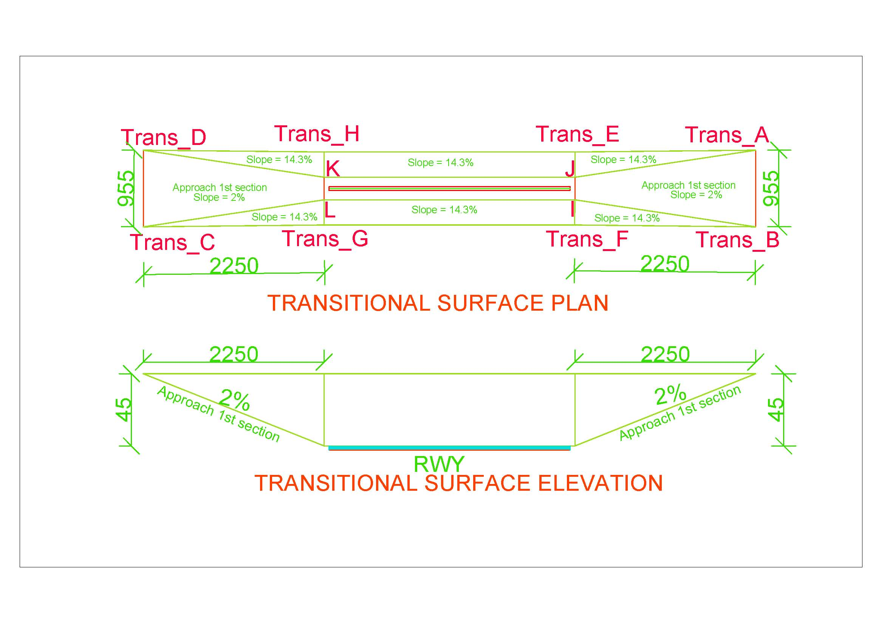

Figure 6. Transitional Surface

### Inner Transitional Surface

|  |  |
| --- | --- |
| Surfaces | Dimension |
| TRANSITIONAL |  |
| Slope_% | 33.3 |

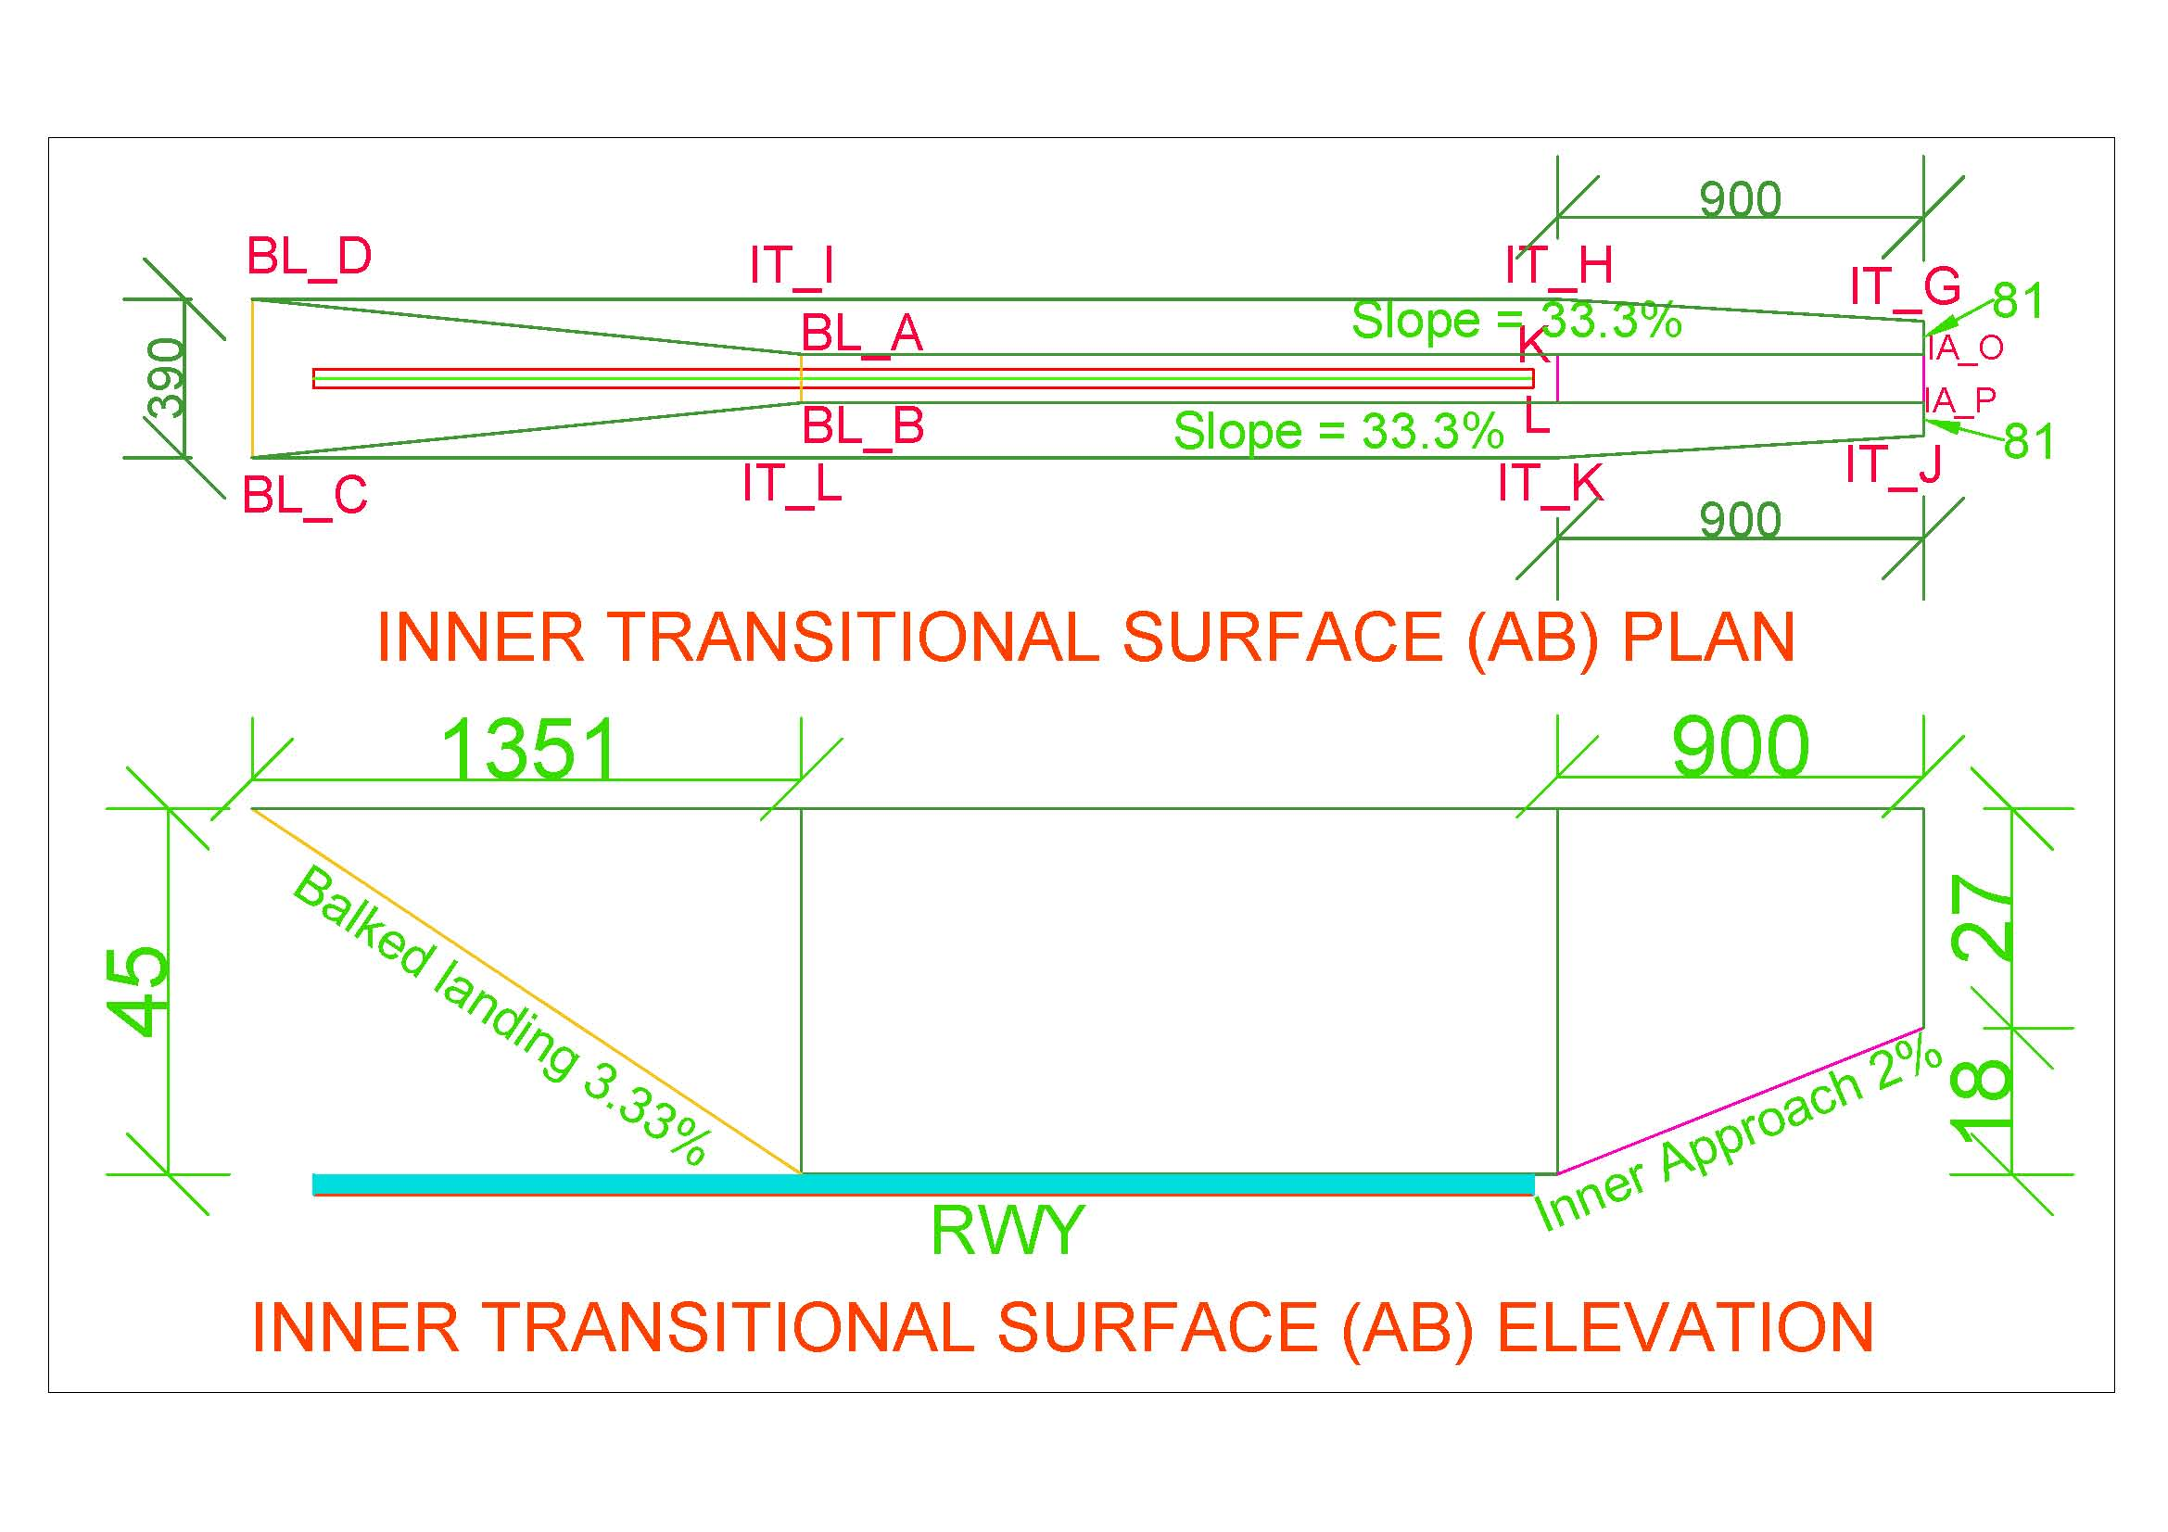

Figure 7. Inner Transitional Surface (AB Side)

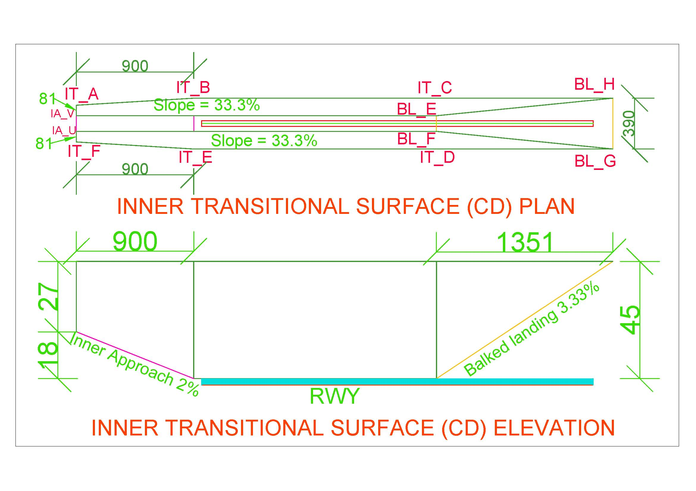

Figure 8. Inner Transitional Surface (CD Side)

### Balked Landing Surface

|  |  |
| --- | --- |
| Surfaces | Dimension |
| BALKED_LANDING |  |
| Length_of_inner_edge_m | 120 |
| Distance_from_threshold_m | 1800 |
| Divergence_% | 10 |
| Slope_% | 3.33 |

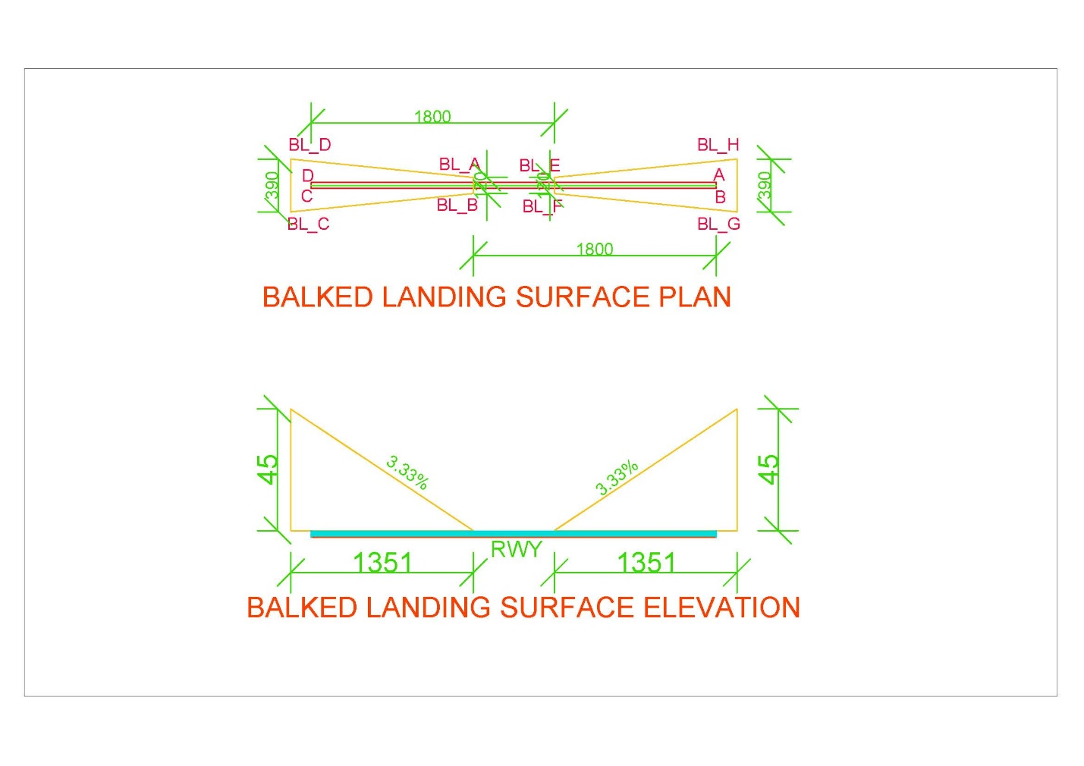

Figure 9. Balked Landing Surface

* *Note:* 
  + *If threshold is displaced by distance ‘d’, Balked landing surface will also be displaced by distance ‘d’ in the direction of displaced threshold.*
  + *In* Figure 16 *“VNBW.txt”, AB_Threshold_displaced_By and CD_Threshold_displaced_By shall be given value d1 and d2 respectively if Threshold AB is displaced by d1 and CD is displaced by d2.*
  + *If thresholds aren’t displaced, value will be zero*

### Take Off Climb Surface

|  |  |
| --- | --- |
| Surfaces | Dimension |
| TAKE_OF_CLIMB_SURFACE |  |
| Length_of_inner_edge_m | 180 |
| Distance_from_RWY_End_m | 60 |
| Divergence_% | 12.5 |
| Final_Width_m | 1800 |
| Length_m | 15000 |
| Slope_% | 2 |

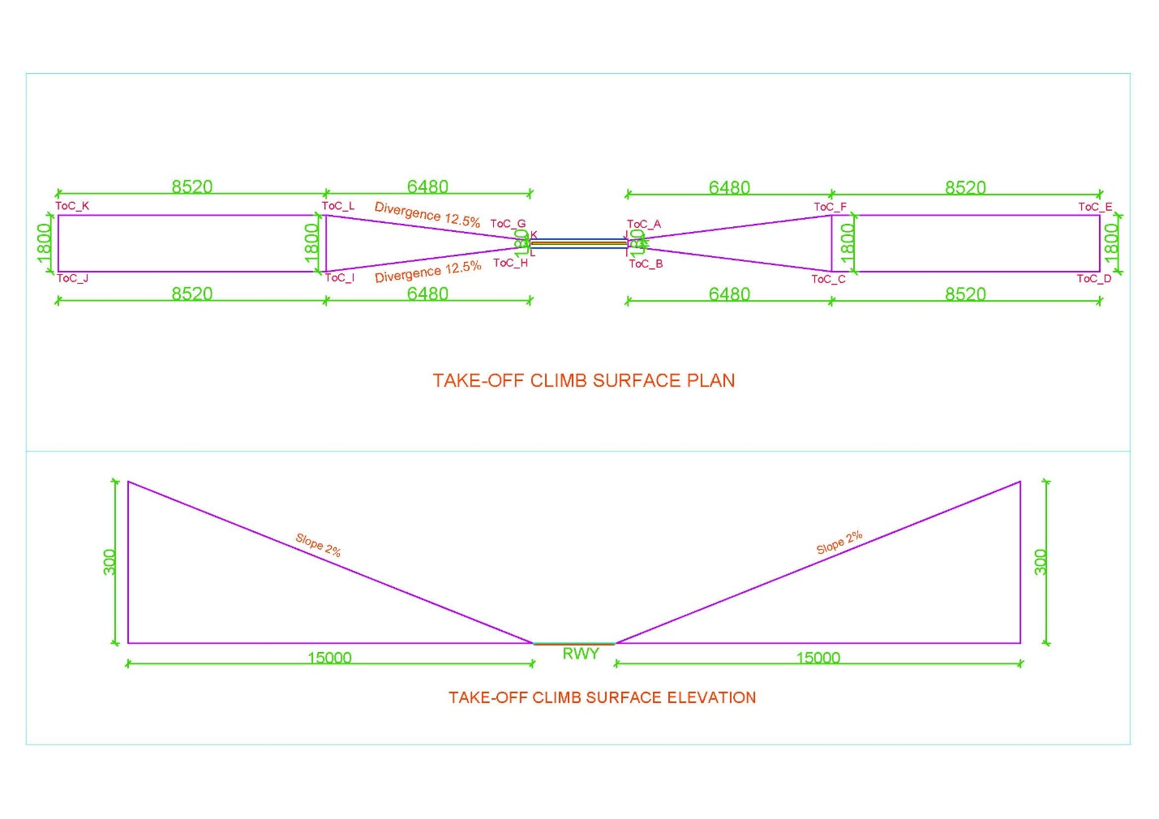

Figure 10. Take off Climb Surface

* *Note:* 
  + *Take-Off Climb Surface starts from 60m end of runway (i.e. RWY strip) or end of clearway, whichever is greater.*
  + *For example, as in* Figure 1*,*
    - *Distance of strip from RWY end (d1) = SWY + strip end = 150+60=210m*
    - *Distance of CWY from RWY end (d2) = 1000 m*
    - *Distance beyond strip end of CWY = 1000-210=790 m = d*
    - *This value i.e., ‘d’ is to be placed for respective end of runway in AB_CLWY_beyond_strip and CD_CLWY_beyond_strip as in* ***Error! Reference source not found.***Figure 16*.*

### Outer Horizontal Surface

|  |  |
| --- | --- |
| Surfaces | Dimension |
| Center at | ARP |
| Radius_m | 15000 |

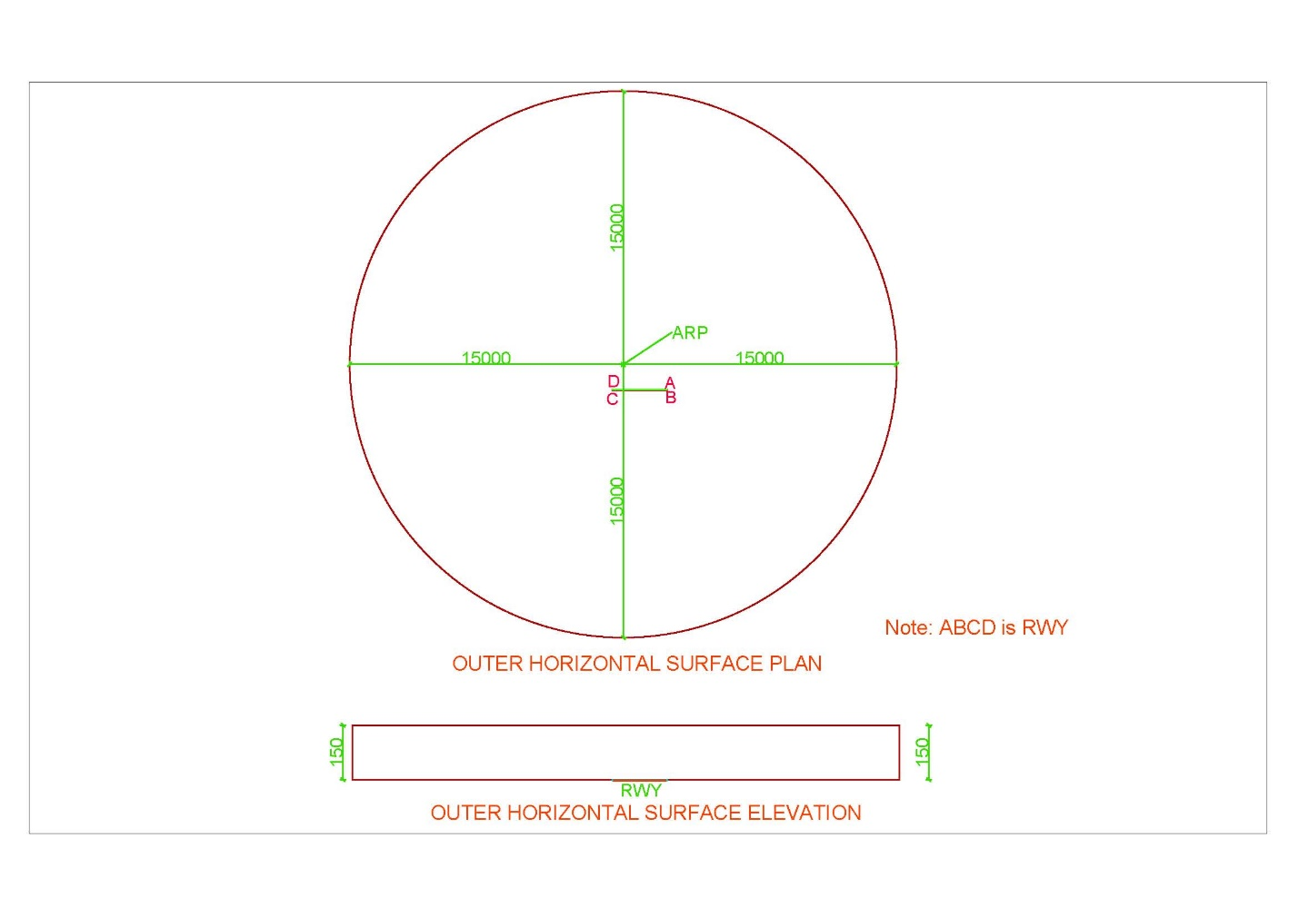

Figure 11. Outer Horizontal Surface

# INTRODUCTION TO SOFTWARE

## Overview of Software

|  |  |
| --- | --- |
| Name of the Software | **CSAY Obstacle Height Calculation** |
| Version | 2023.1 |
| Type | Free and Open source |
| Operating System | Windows 10 (preferable) or higher |
| Display resolution of Monitor screen (Recommended) | 1366 x 768 |
| Setup | No installation required |
| Link to download | <https://github.com/ajayyadavay/CSAYObstacleHeightCalculation> |
| Created/Developed/Programmed by | Er. Ajay Yadav |
| E-mail: | [Civil.ajayyadav@gmail.com](mailto:Civil.ajayyadav@gmail.com) |

## Functions of Software

1. Finds the height of the obstacle
2. Generates OLS for any airport with single runway with correct input of respective Ellipsoid parameters
3. Creates pdf of the report
4. Draws map of Obstacle Limitation surface and plotted point showing distance between runway and obstacle location
5. Creates tippani in Nepali and Letter in Nepali as well as English
6. Exports the route between runway and obstacle and their points to KML file
7. Allows user to Perform database operations: ADD, MODIFY, DELETE, DISPLAY, FILTER
8. Exports the saved/added data to excel
9. Allows user to Auto process which will generate report, tippani, letter, KML and Map saved in a folder
10. Allows user to enter decimal degrees (DD) of location of obstacle and also assists in converting from Degree, Minute and Second (DMS) format to DD.
11. Allows user to draw all the obstacle limitation surfaces or only selected surfaces and the selected OLSs will only be used during calculate
12. Allows user to extract coordinate (latitude and longitude) from map on mouse click
13. Allows user to input multiple obstacle coordinates in “.txt” format, calculates intrusion into OLS and export result to Excel used generally during OLS Survey.

## Limitation of Software

1. This software can be used for airport having only one Runway and not for airport having the parallel or intersecting runways or more than one Runways.

## Layout of Software

1. There are Ten Tabs
2. All the Text boxes labelled with black foreground is input and others are either calculated textboxes or loaded from the ‘*.txt’ files
3. For Auto process, input all required value and click on menu Processing>Auto Process button
4. Textboxes with orange colored label in “General” tab are compulsory input fields
5. All the Combo Boxes have their values loaded from “*.txt” files
6. OLS Map is drawn in “OLS Map” tab
7. At top, there is Menu (File, Database and Processing)

## Input Text files (“*.txt”) and folder

All the text files contain data as per the name of the text files.

*Note1: The user is allowed to only edit the content of text files strictly adhering to the format and user cannot rename or delete the text files or change the location of the text files.*

*Note2: After entering data in specified format in any “.txt” files, don’t press enter to start new lines at the end of file as in* Figure 13 *i.e., the file should be ended with text as in* Figure 12.

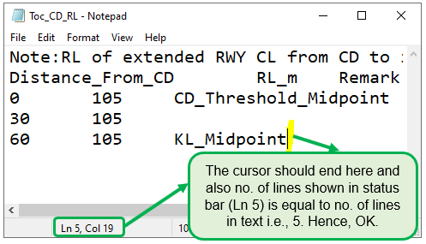

Figure 12. Dos for preparing any input ".txt" files

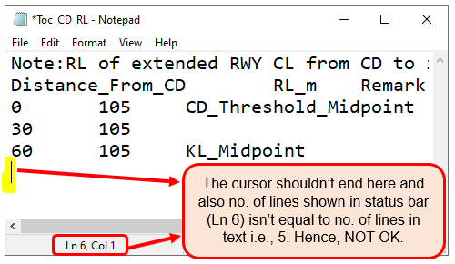

Figure 13. Don'ts for preparing any ".txt" files

Figure 14 shows folders and its content. The user can edit content as per their requirement.

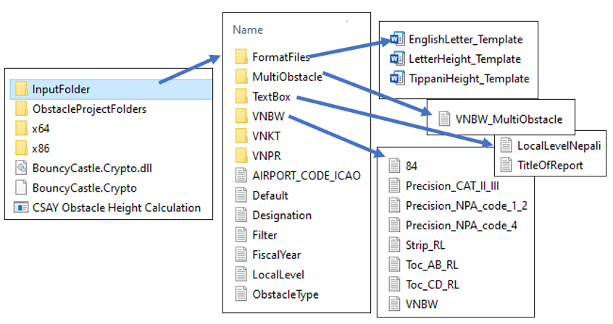

Figure 14. Input folder and its content

### Content of TextBox Folder

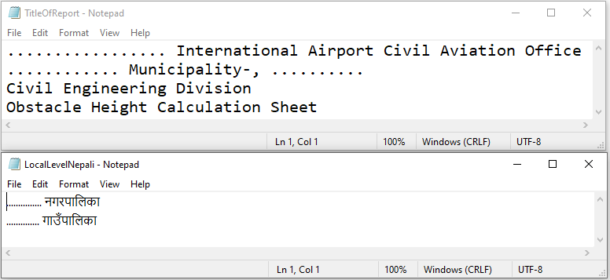

Figure 15. TextBox Folder Content

1. LocalLevelNepali.txt 🡪 contains local level name in Nepali/Devanagari and it should be in the same order as that of English local level name as shown in Figure 18.
2. TitleOfReport.txt 🡪 contains title of the report generated

### Airport code folder content

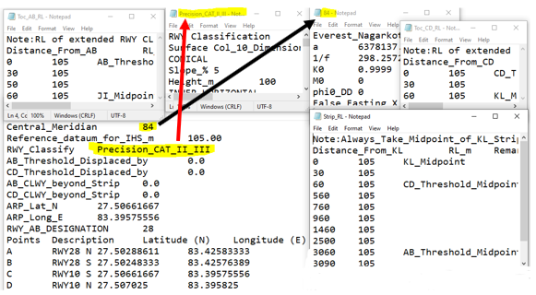

Figure 16. Airport Code (e.g., VNBW) Folder Content

1. “84.txt”
   1. contains parameter of ellipsoid used in 2D projection i.e., to convert latitude and longitude to Easting and Northing and vice-versa.
   2. Instead of “84.txt”, you can rename or create a new file with different longitude, e.g., “87.txt” but “87” should be specified in “VNBW.txt” as value of Central_Meridian.
2. “Precision_CAT_II_III.txt”
   1. contains data of any one column of OLS table of ICAO ANNEX-14, VOL I, chapter 4, which specified dimension of OLS.
   2. Also “Precision_CAT_II_III” should be specified in “VNBW.txt” as value of “RWY_Classify”.
   3. Different filename can be used but should be specified in “VMBW.txt”
3. ToC_CD_RL.txt
   1. This text file contains data of chainage-wise Reduced Level (RL) of extended centerline of Runway staring from the CD side Threshold and continuing along the centerline of clearway or end of Runway strip whichever is greater.
   2. *This filename cannot be changed.*
   3. The maximum RL of contained in this file is used as ground RL for Take-Off Climb Surface at CD Threshold.
4. ToC_AB_RL.txt
   1. This text file contains data of chainage-wise Reduced Level (RL) of extended centerline of Runway staring from the AB side Threshold and continuing along the centerline of clearway or end of Runway strip whichever is greater.
   2. *This filename cannot be changed.*
   3. The maximum RL of contained in this file is used as ground RL for Take-Off Climb Surface at AB Threshold.
5. Strip_RL.txt
   1. Contains data of chainage-wise RL of centerline of strip i.e., centerline of Runway and its extension on both ends beyond thresholds and up to strip end.
   2. *This filename cannot be changed.*
   3. This data is used as ground RL for Transitional surface, Inner transitional surface, Approach and Inner Approach Surface.
   4. Transitional and Inner transitional surfaces use the nearest RL data and these surfaces will be drawn in the chainage specified in this file
   5. For Approach and Inner Approach, the midpoint RL of respective threshold is used and these RL’s are identified by keyword *CD_Threshold_Midpoint* and *AB_Threshold_Midpoint* contained in this file.
   6. The chainage can be any regular interval (e.g., 0, 10, 20, 30, etc.) or irregular interval (e.g., 0, 10, 15, 23, 28, 30, etc.) but staring chainage i.e., zero should always begin at midpoint RL of “KL” near “CD threshold”.
   7. For nomenclature, refer Figure 5 and Figure 34.
6. Airportcode.txt e.g., VNBW.txt
   1. This file can have any ICAO airport code name like “VNBW.txt”, “VNKT.txt”, “VNPR.txt”, etc. Here “VNBW.txt” is used throughout the document as example.
   2. In text file VNBW.txt, Central meridian should be a number e.g., 84 and a filename “84.txt” should be in the same folder containing parameters of ellipsoid in format as shown in Figure 16.
   3. “Reference_dataum_for_IHS_m” contains RL for Inner Horizontal Surface
   4. RWY Classify should contains the filename e.g. “Precision_CAT_II_III.txt” of the file which contains information of OLS dimensions as shown in Figure 16.
   5. AB_Threshold_Displaced_by and CD_Threshold_Displaced_by contains length by which these thresholds have been displaced
   6. AB_CLWY_beyond_Strip contains length of clearway which extends beyond the strip at AB threshold as in Figure 1, this value will be (1000 – 150 – 60) = 790.
   7. CD_CLWY_beyond_Strip contains length of clearway which extends beyond the strip at CD threshold as in Figure 1, this value will be 0 as there is no clearway. Also, these values will be zero when clearway doesn’t extend beyond the Runway strip.
   8. AB_CLWY_beyond_Strip and CD_CLWY_beyond_Strip specifies how far will the Take Off climb surface begins beyond the strip
   9. ARP_Lat_N and ARP_Long_E contains latitude and longitude of ARP published in Aerodrome manual
   10. RWY_AB_DESIGNATION specifies the designation of Runway on AB side and the software itself calculates the designation of CD side.
   11. A,B,C,D are points of the runway corners and contains their respective latitude and longitude. Refer Figure 34, for nomenclature.

### MultiObstacle input format

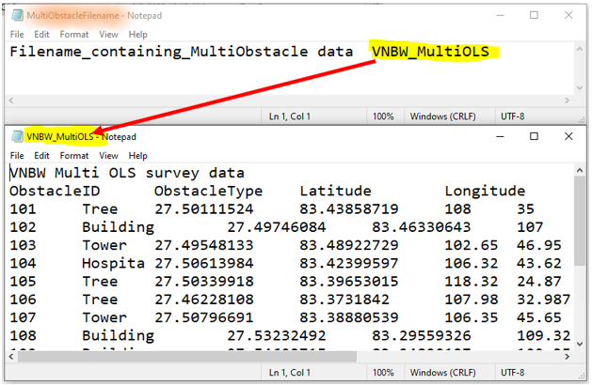

Figure 17. MultiObstacle folder content

1. “AirportCode_MultiObstacle.txt” (e.g., here “VNBW_MultiObstacle.txt”) in the folder MultiObstacle as shown in Figure 14 contains contains data related to different obstacle obtained after OLS survey and it loaded in the first table of Figure 29.

### Others Texfile input format

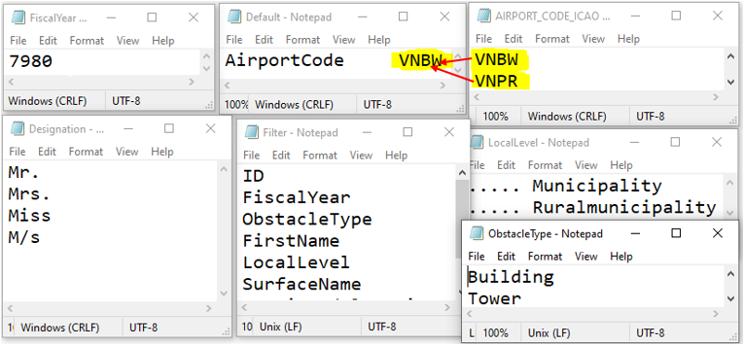

Figure 18. Other textfile content format

1. FiscalYear.txt
   1. Contains fiscal year data in column-wise list format
2. Default.txt
   1. Contains only one airport code among the codes specified in “AIRPORT_CODE_ICAO.txt”, which will be automatically loaded when the software opens by default. This can be changed to VNPR or VNKT or any other name among the list contained in “AIRPORT_CODE_ICAO.txt”
3. “AIRPORT_CODE_ICAO.txt”
   1. contains column-wise list of ICAO airport codes.
   2. However, IATA codes can also be used but all the files and folders should be renamed accordingly
4. Designation.txt
   1. Contains designation that will be put before name of the person/building/tower, etc. whose data is entered
5. Filter.txt
   1. Contains the column name of table shown in Figure 19, which can be used to filter the record in the table
6. LocalLevel.txt
   1. Contains local level name in English and must match the order contained in LocalLevelNepali.txt
   2. These texts are loaded in the combo box as shown in Figure 23 (for English) and Figure 24 (For Nepali/Devanagari)
   3. Selecting any name from “LocalLevel.txt” will automatically load corresponding name from “LocalLevelNepali.txt”.
7. ObstacleType.txt
   1. Contains the type of obstacle name in column-wise list format

## Content of Tab

### Load All Record

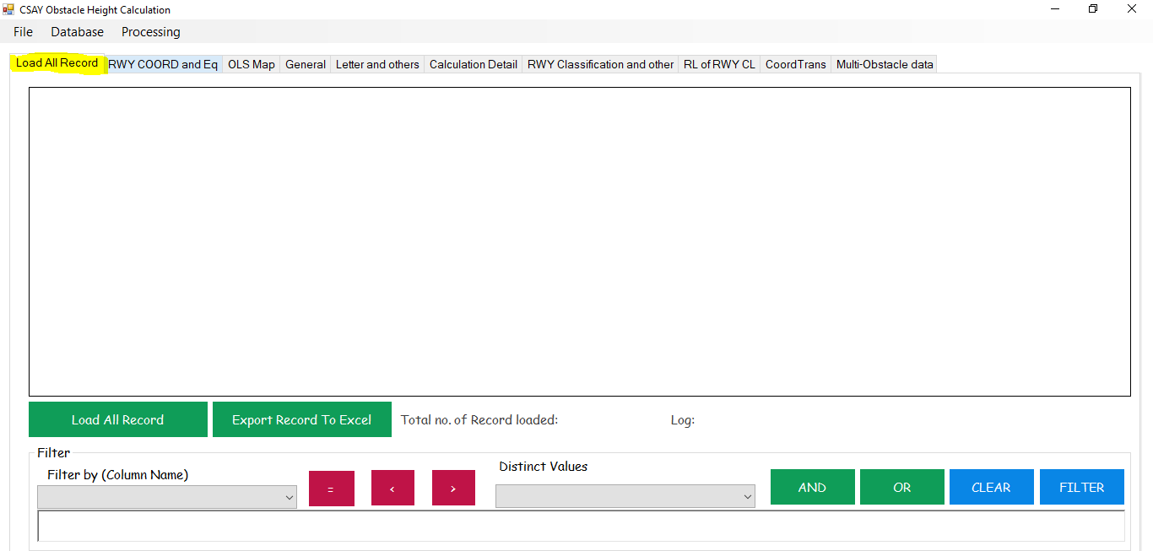

Figure 19. Load all Records Tab

### RWY COORD and Eq

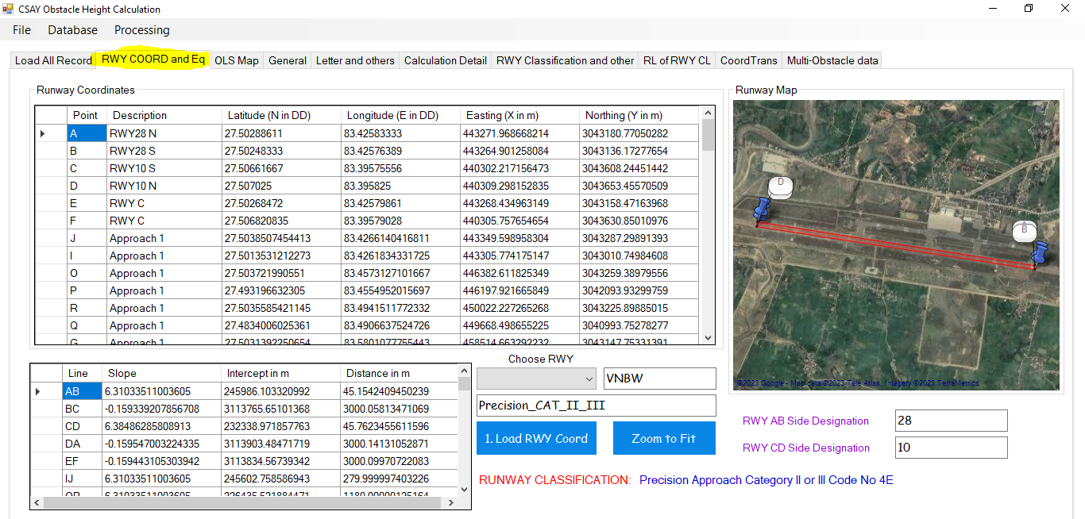

Figure 20. RWY COORD and Eq Tab

1. As in Figure 20, First enter the required data in specified format in text files as in Figure 14
2. Choose RWY
3. A Folder of the same name (Here, it is VNBW) should be present in folder and a file named “VNBW.txt” will be in the folder VNBW as shown in Figure 14 and Figure 16
4. Click button “1. Load RWY Coord” to load and “Zoom to Fit” to fit.
5. As in Figure 14, the “default.txt” contains name of the Airport code which will be automatically loaded, if file exists, when the software opens.
6. Runway Classification name will be loaded from “Precision_CAT_II_III.txt” as shown in Figure 14 and Figure 16.
7. RWY AB side Designation is taken from “VNBW.txt” as in Figure 16 while RWY CD side Designation is calculated by software.

### OLS Map

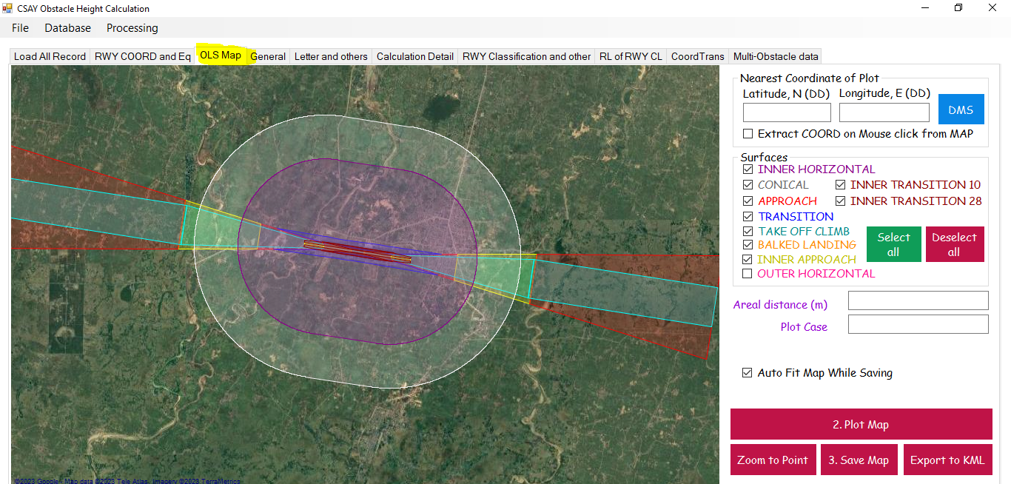

Figure 21. OLS Map Tab

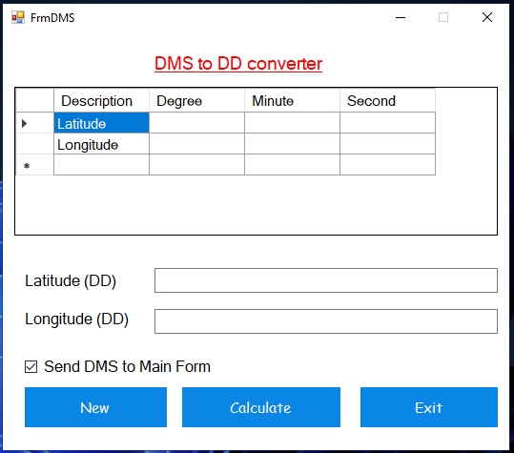

Figure 22. DMS to DD Converter

1. Input latitude and longitude in DD format.
2. Click DMS and enter latitude and longitude in DMS format as in Figure 22.
3. If “Extract COORD on mouse click from Map” is checked on, latitude and longitude text boxes will be filled the latitude and longitude of the map and if checked off, user has to input the coordinate themselves.
4. Under surfaces, select the required surfaces to **display and calculate.**
5. As shown in Figure 21, Outer horizontal surface is not checked (i.e., not selected) so, it is not displayed and also will not be used to calculate OLS.
6. Click button “2. Plot Map” to plot the obstacle and runway point and calculate areal distance
7. If “Auto Fit Map While Saving” is checked on, the map will be autofit to the points plotted and that map will be saved but if it is checked off, the user can adjust the map to desired zoom level by scrolling mouse wheel and then click “3. Save Map”
8. Click “Export to KML” to export the points of runway, obstacle and line joining them to KML file
9. “Zoom to Point” zooms map to the plotted point

### General

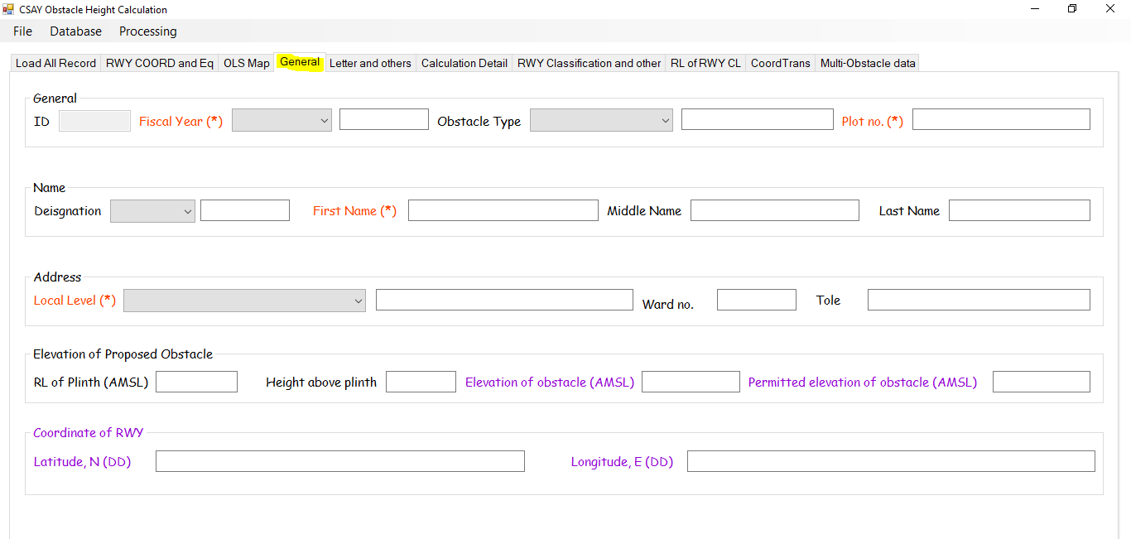

Figure 23. General Tab

1. All orange label marked with (*) are mandatory fields/textboxes
2. All black labelled fields are to be entered by user
3. Other are calculated or loaded from text files

### Letters and others

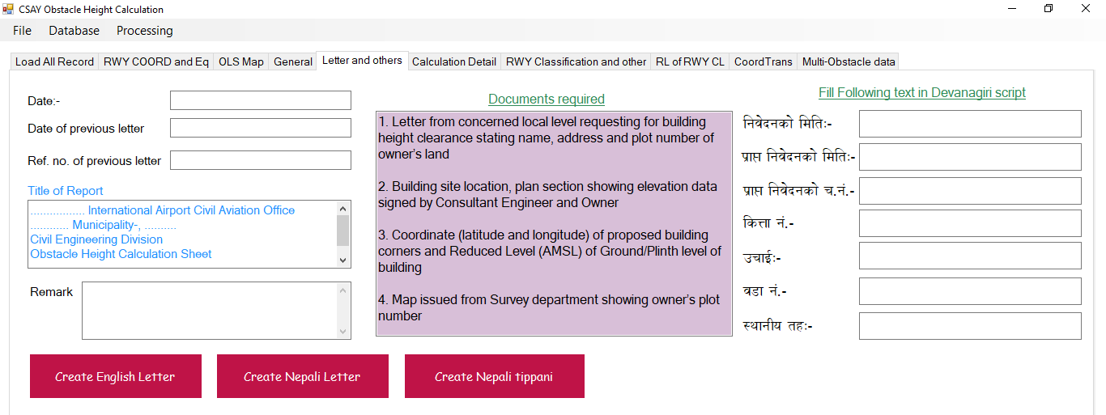

Figure 24. Letters and Others Tab

1. All black labeled are input
2. Blue colored fields are loaded form text files as shown in Figure 14.
3. No need to write in Devanagari i.e., Nepali because when you input in English, these Devanagari fields will be automatically filled
4. “Create English Letter”, “Create Nepali Letter” and “Create Nepali Tippani” button will create letter and Tippani in the format contained in “FormatFiles” folder as shown in Figure 14.

### Calculation Detail

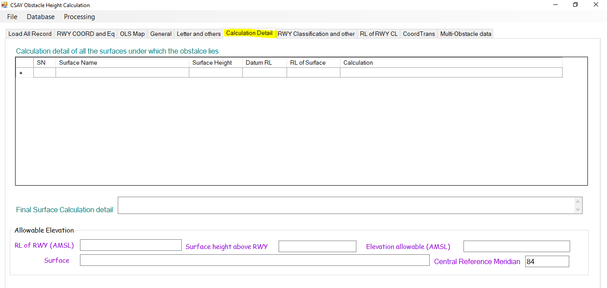

Figure 25. Calculation Detail

1. All the OLS below which the obstacle lies, will be listed with detailed calculation in the table as shown in Figure 25.
2. The minimum elevation data and corresponding surfaces will be shown in the text boxes and that shall be added to the table as shown in Figure 25.

### RWY Classification and other

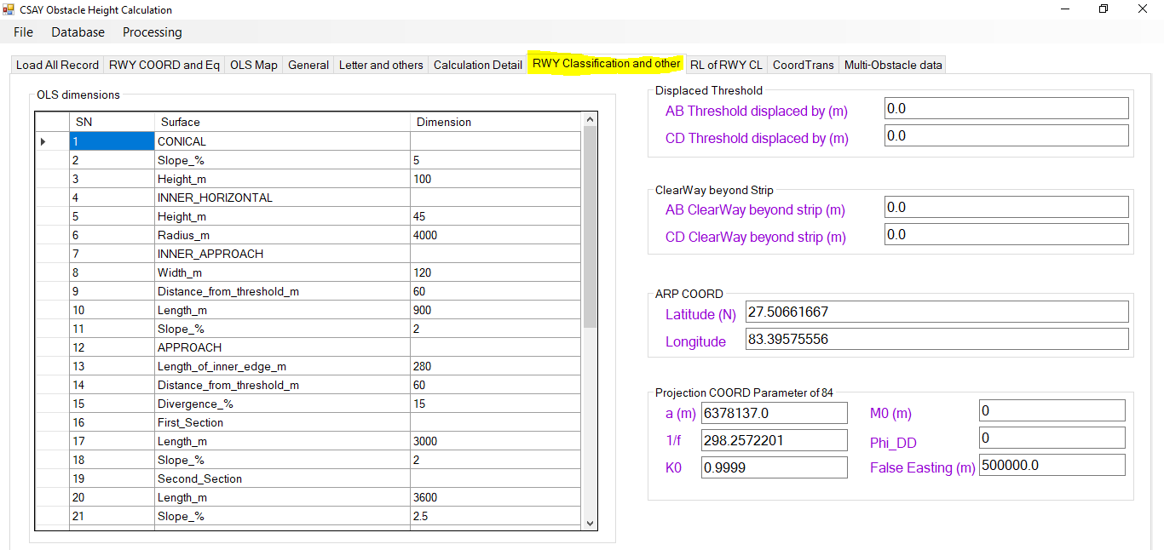

Figure 26. RWY Classification and other Tab

### RL of RWY CL

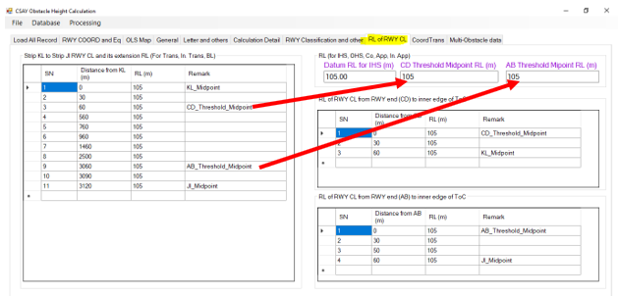

Figure 27. RL of RWY CL tab

1. After the user prepare input files as shown from 3.5 to 3.5.4, the tables and textboxes shown in Figure 27 will be automatically loaded.

### Coord Trans

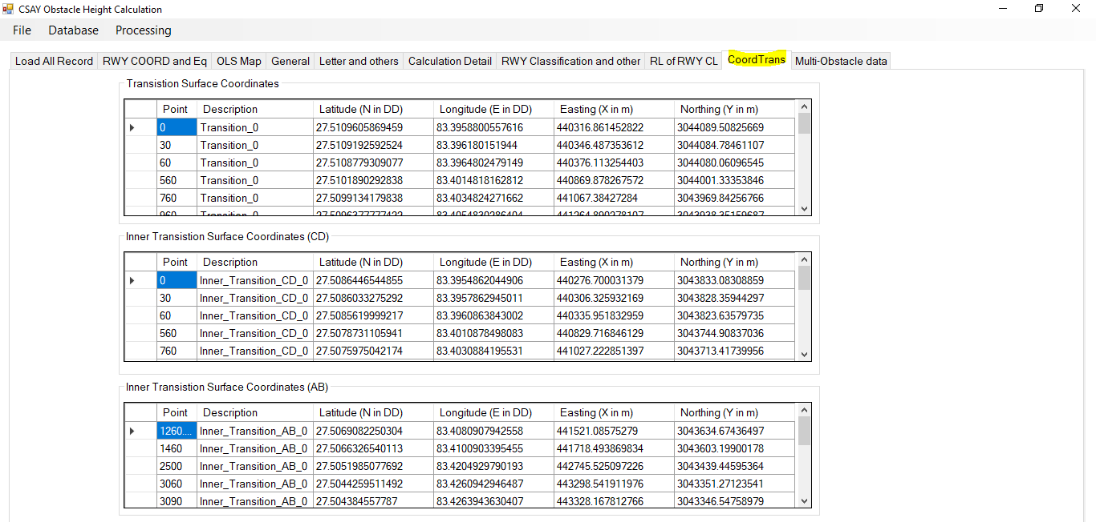

Figure 28. Coord Trans tab

1. The tables in this tab are automatically calculated after the user prepare input files as shown from 3.5 to 3.5.3

### Multi-Obstacle data Tab

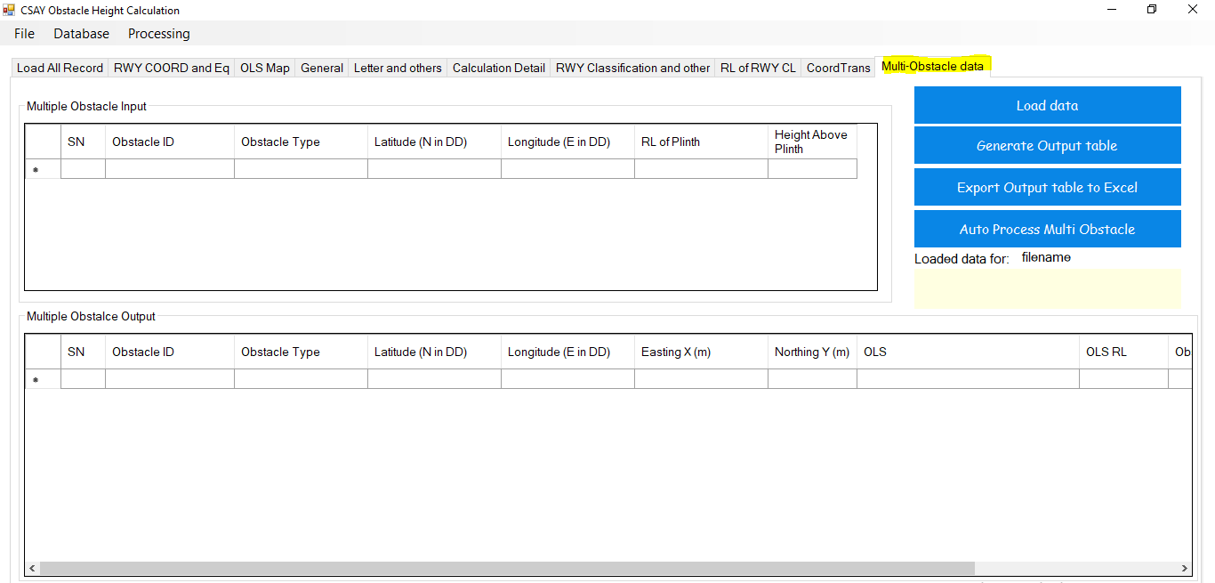

Figure 29. Multi-Obstacle data tab

1. The first table is input table which takes input on clicking button “Load data” from filename “AirportCode_MultiObstacle.txt” i.e., for VNBW, it will be “VNBW_MultiObstacle.txt” as shown in Figure 17.
2. Button “Generate Output table”, calculated the RL of obstacle and OLS and intrusion, if any
3. “Export Output to Excel” exports to excel
4. “Auto process Multi Obstacle” automatically performs action from (1) to (3), given that the input files are in format
5. It can be used in OLS Survey
6. These data are not added to the database of the software and user has to save excel files themselves
7. While calculating data, violet colored progress bar appears

### Menu

When any menu is clicked or any process occurs, message is displayed in the white box and when file is saved, location of last saved file is displayed in the orange region as shown in Figure 32.

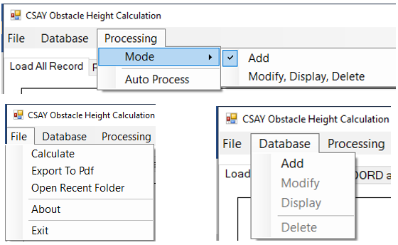

Figure 30. Menu

1. File menu
   1. Calculate
      1. After the user prepare input files as shown from 3.5 to 3.5.3, the use should click on “2. Plot map” of Figure 21
      2. Then users need to input “RL of plinth (AMSL)” and “Height above plinth” as in Figure 23
      3. Then user can click on File>Calculate and view calculation details as shown in Figure 25.
   2. After calculation and input of all black labelled fields, use can export report and English letter to pdf by clicking File>Export to Pdf
   3. “Open Recent Folder” Opens recently calculated and saved files
   4. “About” open about form as in Figure 31.
   5. “Exit” closes the software
2. Database menu
   1. “Add” to add data to database and ID auto-increases and All the projects are saved in Folder “ObstacleProjectFolders” as shown in Figure 14.
   2. “Modify” to modify the existing data
   3. “Display” to display the data after input of ID in General tab as in Figure 23
   4. “Delete” to delete the existing data
3. Processing
   1. Mode>Add
      1. When this mode is checked, Database>Add will be enabled, Project ID text field will be disabled in General tab as shown in Figure 23 and user will be allowed to add data
   2. Mode>Modify, Display, Delete
      1. When “Modify, Display, “Delete” is checked on, “Delete”, “Modify” and “Display” of Database menu will be enabled and File>Add will be disabled and Project ID of General tab (Figure 23) will be enabled for user to input ID to display, delete or modify record.
      2. The ID can be known by clicking on button “Load All Record” of Figure 16
   3. Auto Process
      1. Firstly, prepare input files from 3.5 to 3.5.4
      2. Choose required airport code and click on “1. Load RWY COORD” as shown in Figure 20.
      3. Input coordinates in latitude and longitude format in respective fields as shown in Figure 21. OLS Map Tab.
      4. Input all other required fields of General tab (Figure 23) and letter and others tab (Figure 24)
      5. Click on Processing>Auto Process and wait unit 100% processing is complete to generate reports, letters, Tippani, calculate obstacle elevation, export KML and save map.

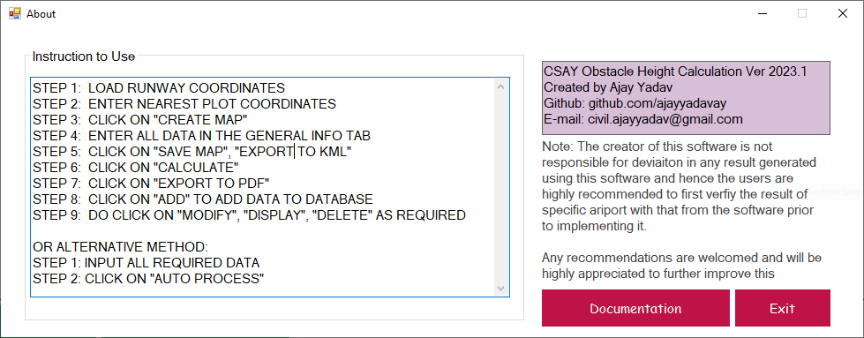

Figure 31. About



Figure 32. Message and recently saved location (Orange region)

### Filter



Figure 33. Filter

1. Format of Filter is –
   1. ‘FirstName’=’Alpha’ OR ‘ObstacleType’=’Building’
   2. Those records will be shown in the table of Figure 19 having First name as ‘Alpha’ or Obstacle type as ‘Building’
   3. The user can use different such combination of filter
   4. Button “Clear” will clear the filter text field
   5. Button “=”, “<”, “>”, “AND”, “OR” have will input these texts in filter field
   6. When the user selects the “Filter by (Column Name)” loaded from “Filter.txt” (Figure 18), combo box “Distinct Values” will be automatically loaded.
   7. Distinct values of any column are the distinct values saved in the database under the same column of table Figure 19.

## Nomenclature of Runway corners

1. The naming of corners of Runway corners shall be according to Figure 34.
2. Reference runway is RWY 10-28
3. Non-reference runway is any runway other than the reference runway i.e., RWY 10-28
4. To name any non-reference runway (i.e., runway other than RWY 10-28),
   1. Draw the centerline runway edge strip rectangular line of reference and the non-reference runway
   2. Rotate the reference runway i.e., RWY 10-28 about mid-point of centerline of RWY in such a that all the following conditions are satisfied-
      1. AB should always be below the EW line
      2. CD should always be above the EW line
      3. ABCD should be in anti-clockwise direction
      4. AB and CD should be shorter sides i.e., along width of RWY
      5. AD and BC should be longer sides i.e., along the length of RWY
   3. Then get the latitude and longitude of corners A, B, C and D from google earth, GPS, etc. and those coordinates in Airport code text file (e.g., VNBW.txt, VNKT.txt, VNPK.txt, etc.) in the format specified as in Figure 16.

*Note:*

1. *If the naming order is wrong or not as per specified, OLS cannot be drawn correctly.*
2. *Since the software code was written with respect to RWY 10-28 and parameters were then set for other runways so, RWY 10-28 is regarded as reference runway.*

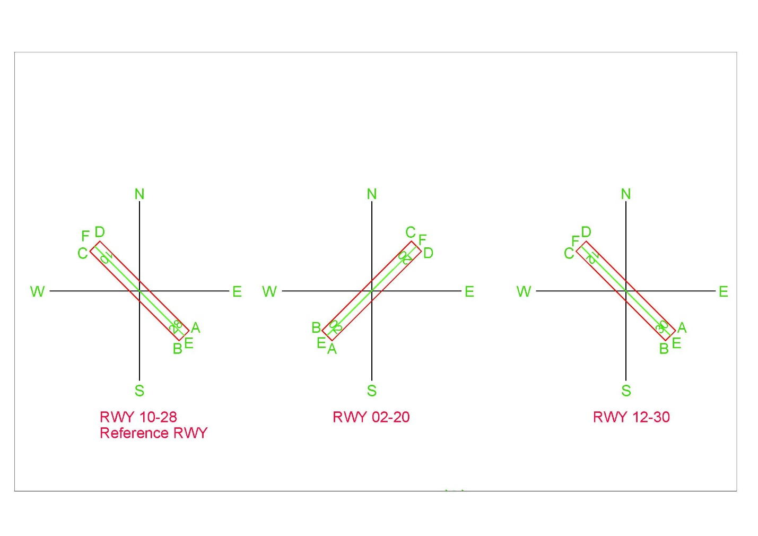

Figure 34. Runway corner nomenclature

## Plot case of Obstacle

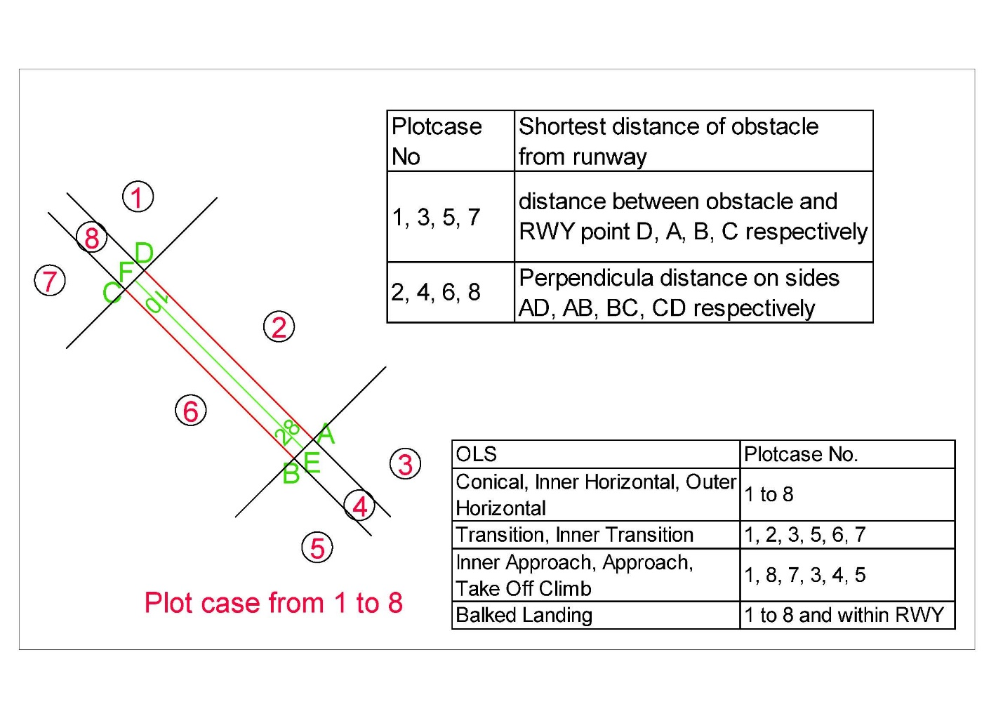

Figure 35. Plot case of obstacle

1. As shown in Figure 35, there are 8 plot cases i.e., 8 possible locations of obstacle with respect to the runway
2. The first table shows how to find the shortest distance of the obstacle from the runway i.e., to find distance, the second point is the obstacle itself and the first point is as described in the table varying according to plot case
3. The second table shows how the particular OLS has spread over few plot cases e.g., Conical exists in all plot cases, Transition surface lies in plot case 1,2,3,5,6 and 7 and transitional surface cannot lie in plot case position 4 and 8, etc.

## Output

### Report

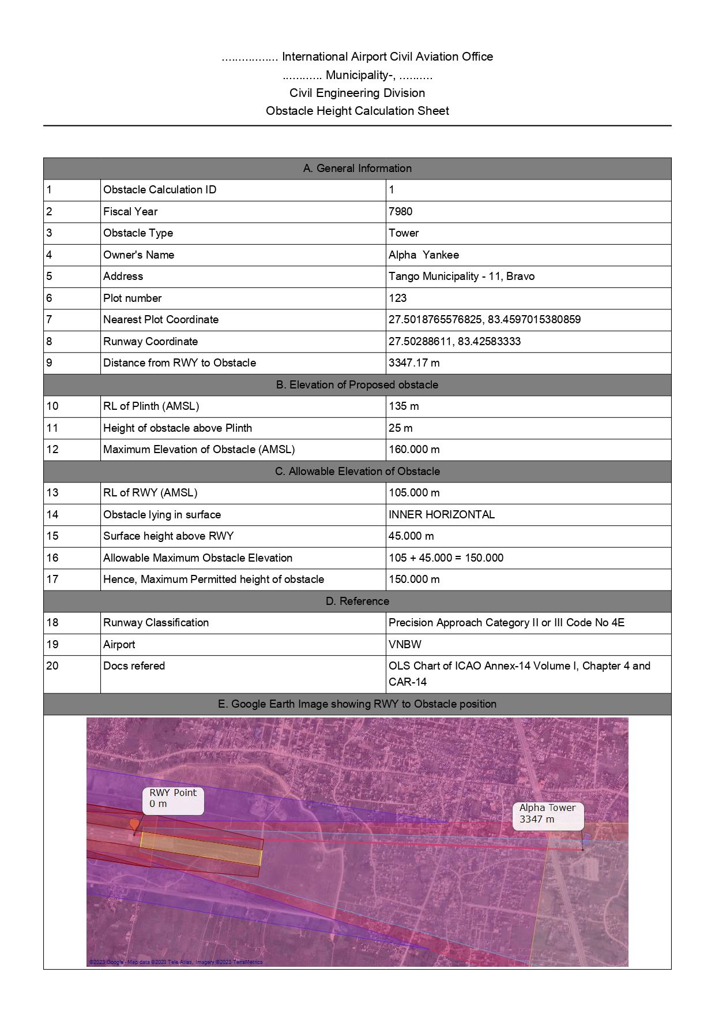

### Letter in Nepali

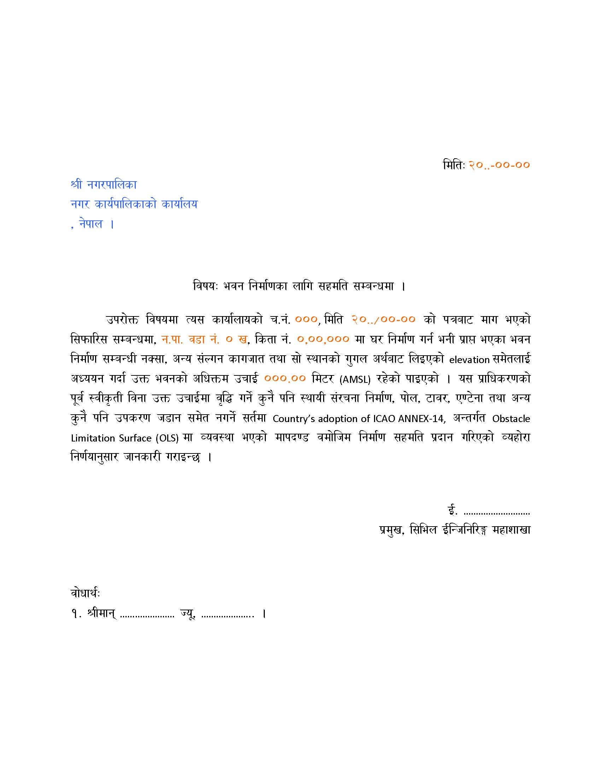

1. Note: In InputFolder>FormatFiles>LetterHeight_Template.dotx as shown above, the orange colored text is not be deleted or edited as they are bookmarked and software replaces these orange colored text with the calculated and user-input data.
2. However, the black texts can be edited as required and saved with same file name.
3. Bookmarks: Date_BM_Letter, Elevation_ Letter, OwnerLocation_BM_ Letter , PlotNo_BM_ Letter, PrevDate_BM_ Letter, RefNo_BM_ Letter

### Tippani in Nepali

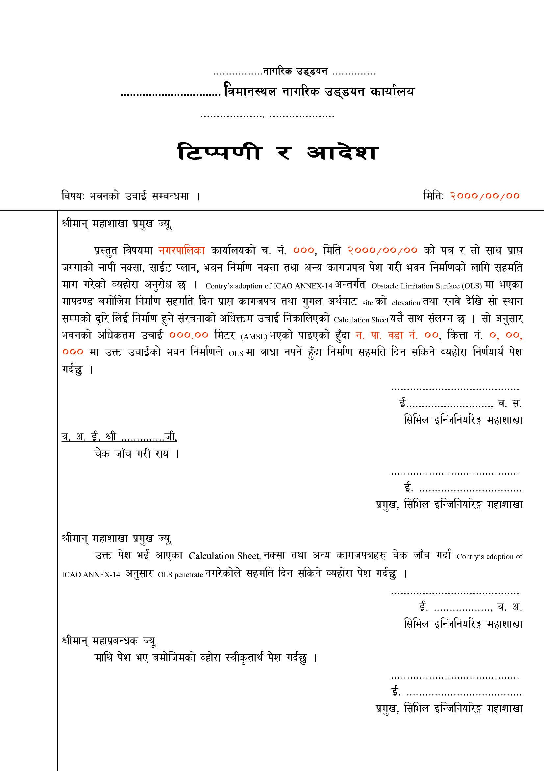

1. Note: In InputFolder>FormatFiles>LetterHeight_Template as shown above, the orange colored text is not be deleted or edited as they are bookmarked and software replaces these orange colored text with the calculated and user-input data.
2. However, the black texts can be edited as required and saved with same file name.
3. Bookmarks: Date_BM_Tippani, Elevation_BM_Tippani, LocalLevel_BM_Tippani, OwnerLocation_BM_Tippani, PlotNo_BM_Tippani, PrevDate_BM_Tippani, RefNo_BM_Tippani

### Letter in English

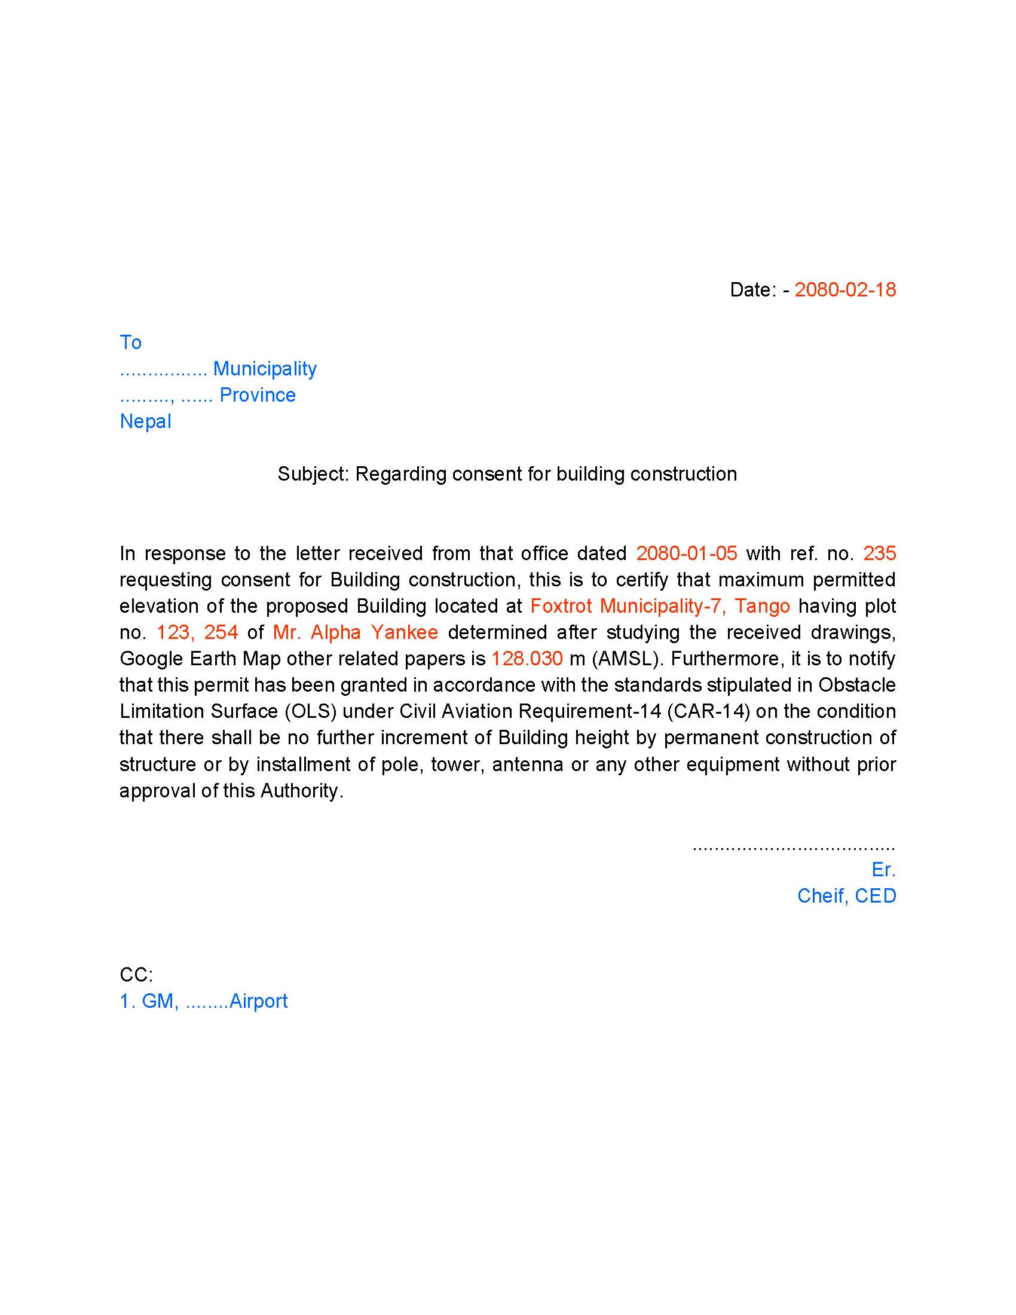

1. Note: In InputFolder>FormatFiles>LetterHeight_Template.dotx as shown above, the orange colored text is not be deleted or edited as they are bookmarked and software replaces these orange colored text with the calculated and user-input data.
2. However, the black texts can be edited as required and saved with same file name.
3. Bookmarks: Date_El, Prev_Date_EL, Ref_no_EL, Address_EL, Plot_No_EL, Name_EL and RL_EL.

## Steps to calculate Obstacle Height with Auot-Process

The following steps shall be followed to calculate Obstacle height

1. Prepare input in all the text files as in Figure 14
2. Open the application

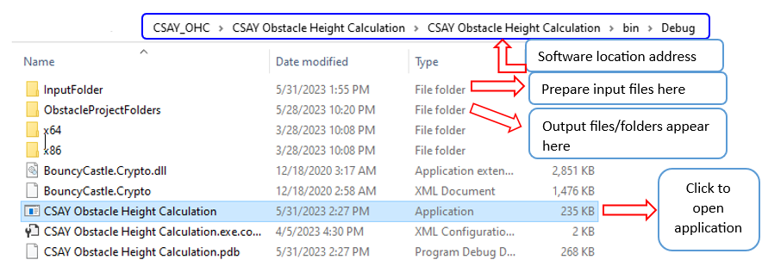

Figure 36. Software Executable file Location

1. The screen as in Figure 19 appears
2. Load RWY location data as in Figure 20
3. Navigate through different tabs and input all the fields labelled black in color as in Figure 21 to Figure 24.
4. Click “Auto process” from menu Processing>Auto Process Figure 30
5. The output will be saved in “ObstacleProjectFolders” as shown in Figure 36.
6. All records are stored in “ObstacleHeightRecord.sqlite3” located in the same as the application itself.

Functions/Features of the Software

* Finds the height of the obstacle, plots OLS, generates report, letters and Tippani, export plotted points to KML
* Generates OLS for any airport with single runway
* Perform database operations: ADD, MODIFY, DELETE, DISPLAY, FILTER
* Draws and calculates the selected OLS
* Allows user to extract coordinate (latitude and longitude) from map on mouse click
* Allows user to input multiple obstacle coordinates in “.txt” format, calculates intrusion into OLS and export result to Excel used generally during OLS Survey.

Er. AJAY YADAV

CSAY OBSTACLE HEIGHT CALCULAION

(A Free and Open-Source Software)

Version 2023.1